1.- In this screen we need to see directly the names of the employees and the vehicles.

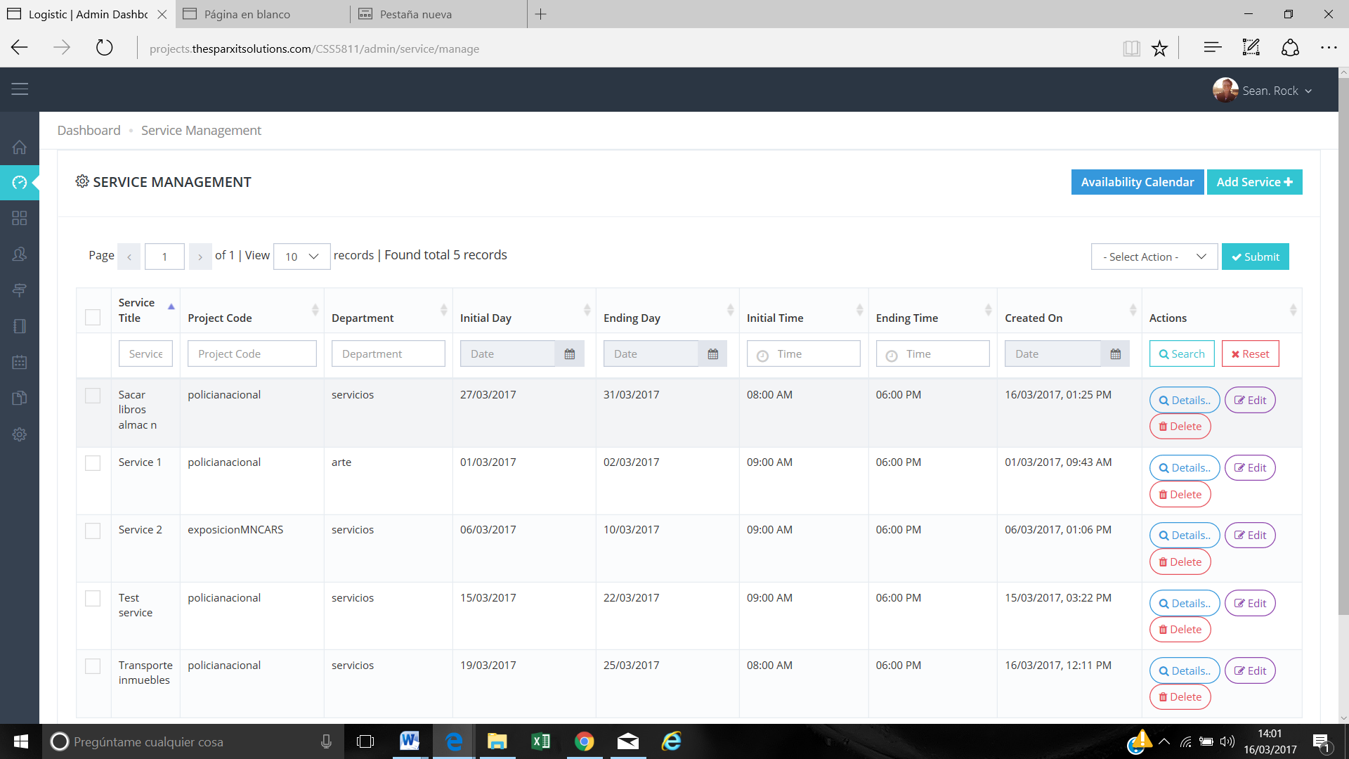

For example we have filtered through one starting day and We cannot see the people and the vehicles assign to this project.

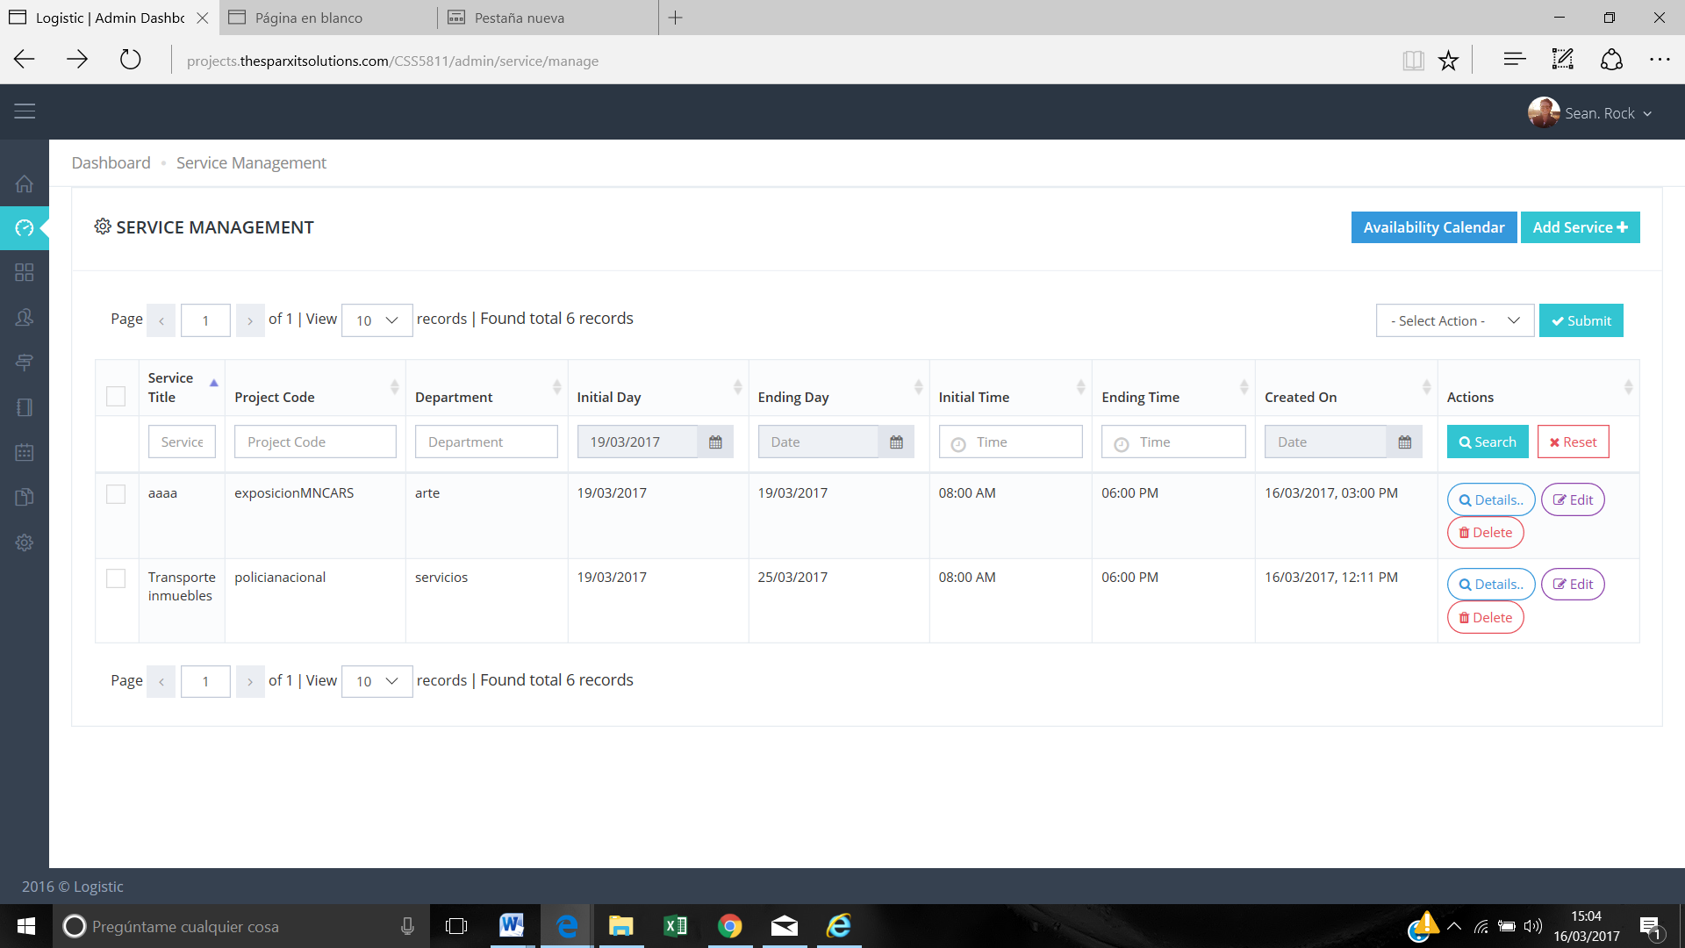

We need to be able to see employee and vehicles without clicking details.

In this screen we want to take out Service Title and Created On and add in this screen Employee and Vehicles assign.

**Reply:** Can you please share the order in which it will be display because each service has multiple entries on daily basis and resources can be modified on daily basis.

For eg. 2 employee / 1 vehicle on 1 Feb and 3 employee / 2 vehicles on 3 Feb. etc.

**Answer:** Maybe we can take out the column “Tittle” and “Created on date” and add Employees and Vehicles.

**>> We need to decide layout.**

2.- We need to have the available employees in green and unavailable employees in red. -

**Reply:** CSS does not support for coloring drop-down options, we are trying to find solution for this.

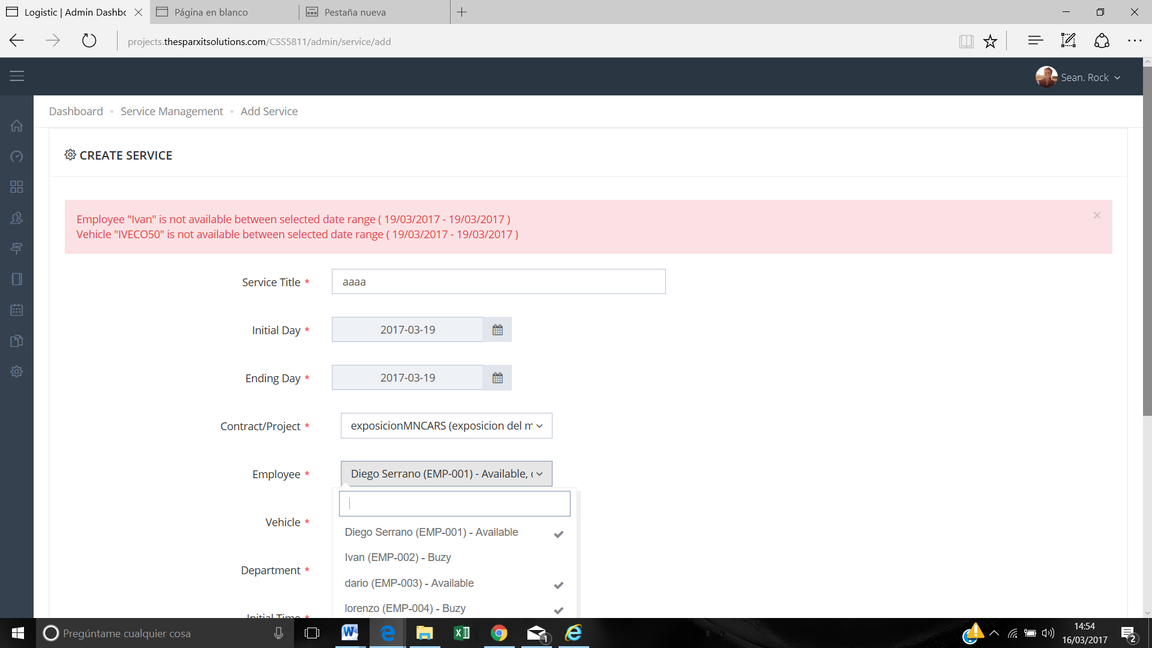

**Answer:** Maybe this point is easier add Available or Unavailable. Show the name and in the right or left part A or U.

**>> Done**

3.- Is it possible to add the picture from the employee as well in this picture ?

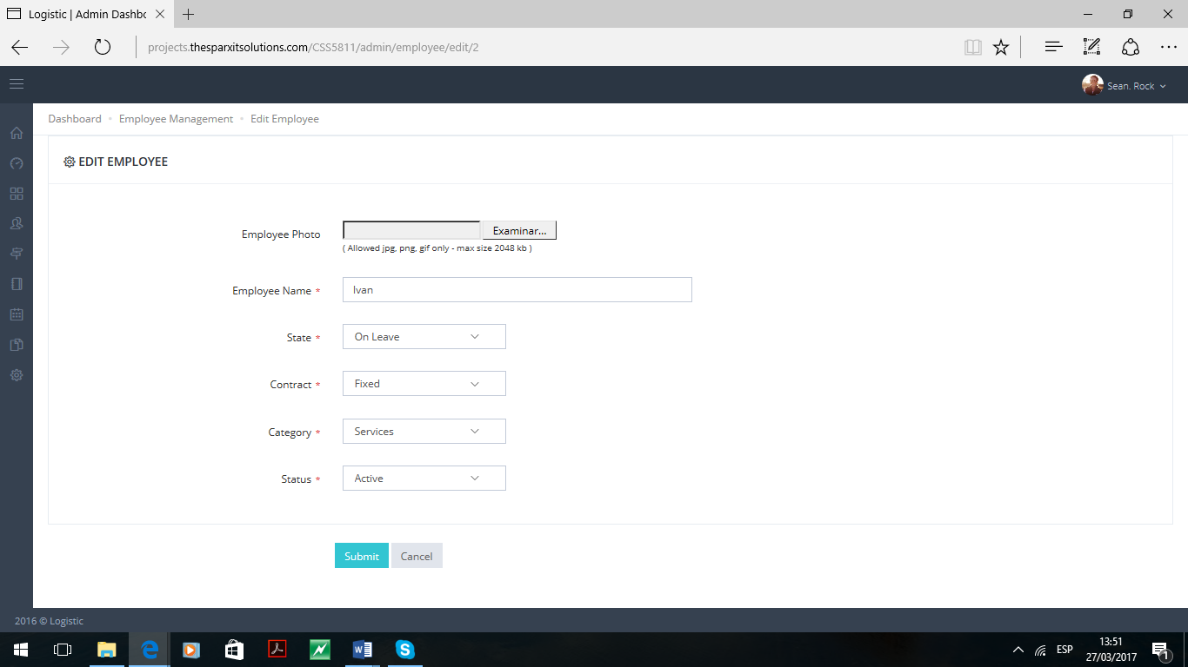

**>> It is Extra Scope Work, We are checking the feasibility with current dropdown.**

4.- When the user opens to one day it’s not possible to see all the personal and vehicles. We need to see them.

Reply: Done

but we need to change the design

A little bit more pretty

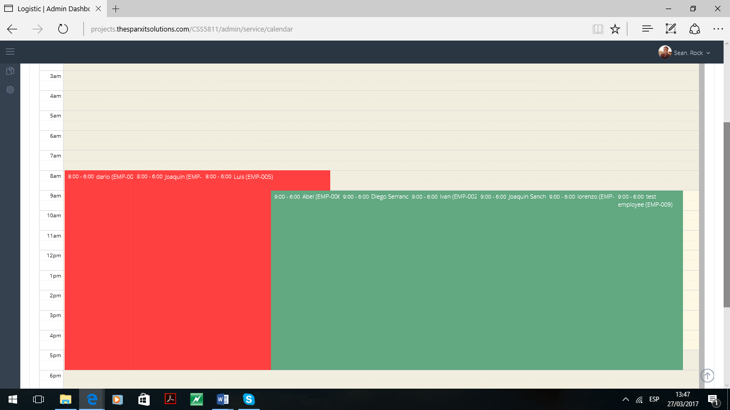

**>> Current calendar design is based on project theme, Any customization in calendar will be considered as Extra scope. Please explain your design need.**

5.- After creating a service the app crashes every time sometimes afterwards the service has been created. But we had to sign up again.

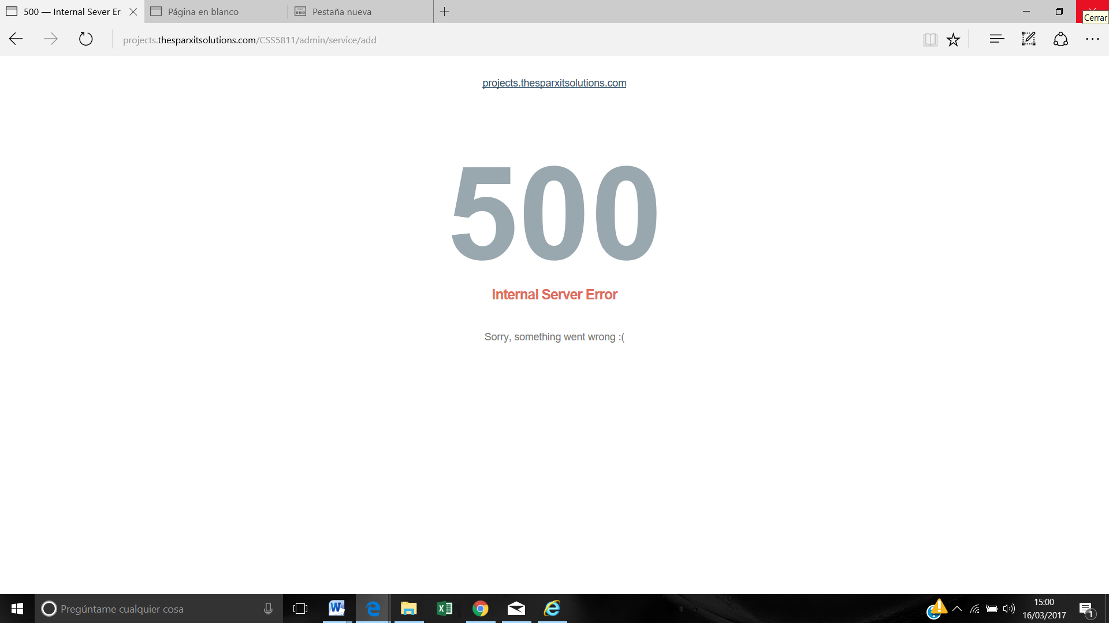

**Reply:** It is server-side internal issue, if you face this issue frequently then let me know we will try to move the project on another server.

**Answer:** we can move it to another server

**>> We have moved it to other server :**

**http://dev.demosparx.in/CSS5811/**

6.- And we need to translate the screens.

**>> we have two options**

**1. Add Google Translate Plugin ( Less Time )**

**2. Convert project into multilingual ( More time than google translate )**